**A1:STEPS USED TO CREATE FORENSIC CASE FILE**



I opened Autopsy by double-clicking on the Autopsy icon found on the desktop.



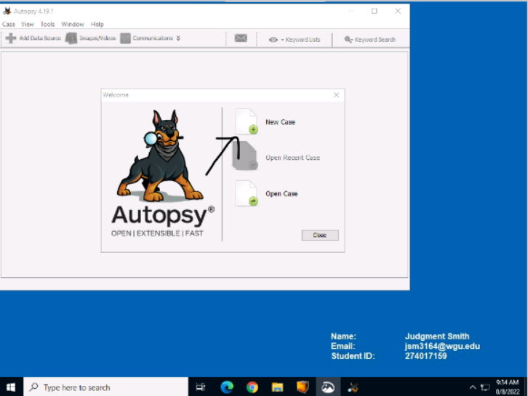

I created a new case by clicking on the new case icon.



I clicked on the “browse” button to select the base directory.



I placed the new case in the “Evidence Files” folder.

This screenshot shows the name and location of the new case.

I filled out the case number and Examiner name with my student information as instructed.

**A3:SUMMARY OF FINDINGS AND CONCLUSIONS**

I selected the default settings as instructed.



I selected the Disk Image type for the Data Source.



The disk image in the folder.



I selected the appropriate system image as instructed.

I accepted the default settings for the Ingest as instructed.

A screenshot showing that the data source was recognized and added to the local database.

The data source opened in Autopsy.

All of the deleted files that were found on the system.



I selected and right-clicked on the deleted files and selected “Extract File(s)”.

I selected the export location for the deleted files.

A screenshot of a pop-up indicating that the files were successfully exported.

The exported deleted files in the Windows File explorer.

A deleted confidential file opened in a web browser.

A deleted confidential file opened in a web browser.

A deleted file related to buying and selling with crypto opened in a web browser.

A deleted confidential file opened in a web browser.

A deleted confidential file opened in a web browser.

A deleted file related to crypto laundering opened in a web browser.

A deleted confidential file opened in a web browser that was renamed.

A deleted confidential file opened in a web browser that was renamed.

A deleted file related to buying and selling with crypto opened in a web browser renamed.

A deleted confidential file opened in a web browser that was renamed.

A deleted confidential file opened in a web browser that was renamed

A deleted file related to crypto laundering opened in a web browser renamed.

A screenshot of metadata found on the system.



A keyword hit for an email address.



The list name with one keyword hit.



The list name with one keyword hit.



The source file with the keyword hit.



The unallocated space with the keyword hit.



I right-clicked and selected “View in New Window”.

The unallocated space segment with a keyword hit opened in a new window.



A screenshot showing mentions of bitcoin.

Confidential files that contain both business plans and diagrams detailing the drilling strategy, were found on the computer. Documents related to cryptocurrency and money laundering were also found on the device. The data on his computer found his computer was above his clearance and strongly suggests a violation of company policy. In addition to that, suspicious data related to crypto laundering suggests that he was selling data possibly to competitors.

The data found on his computer suggest criminal activity.